**Develop a Python script**

|  |  |
| --- | --- |
| Date | 10 November 2022 |
| Team ID | PNT2022TMID28791 |
| Project Name | Project – Smart solution for railways |
| Maximum Marks | 4 Marks |

Smart solution for railways

# Create a code snippet using python to

1. Extract weather data from Open Weather Map using APIs
2. Send the extracted data to the cloud
3. Receive data from the cloud and view it in the python compiler

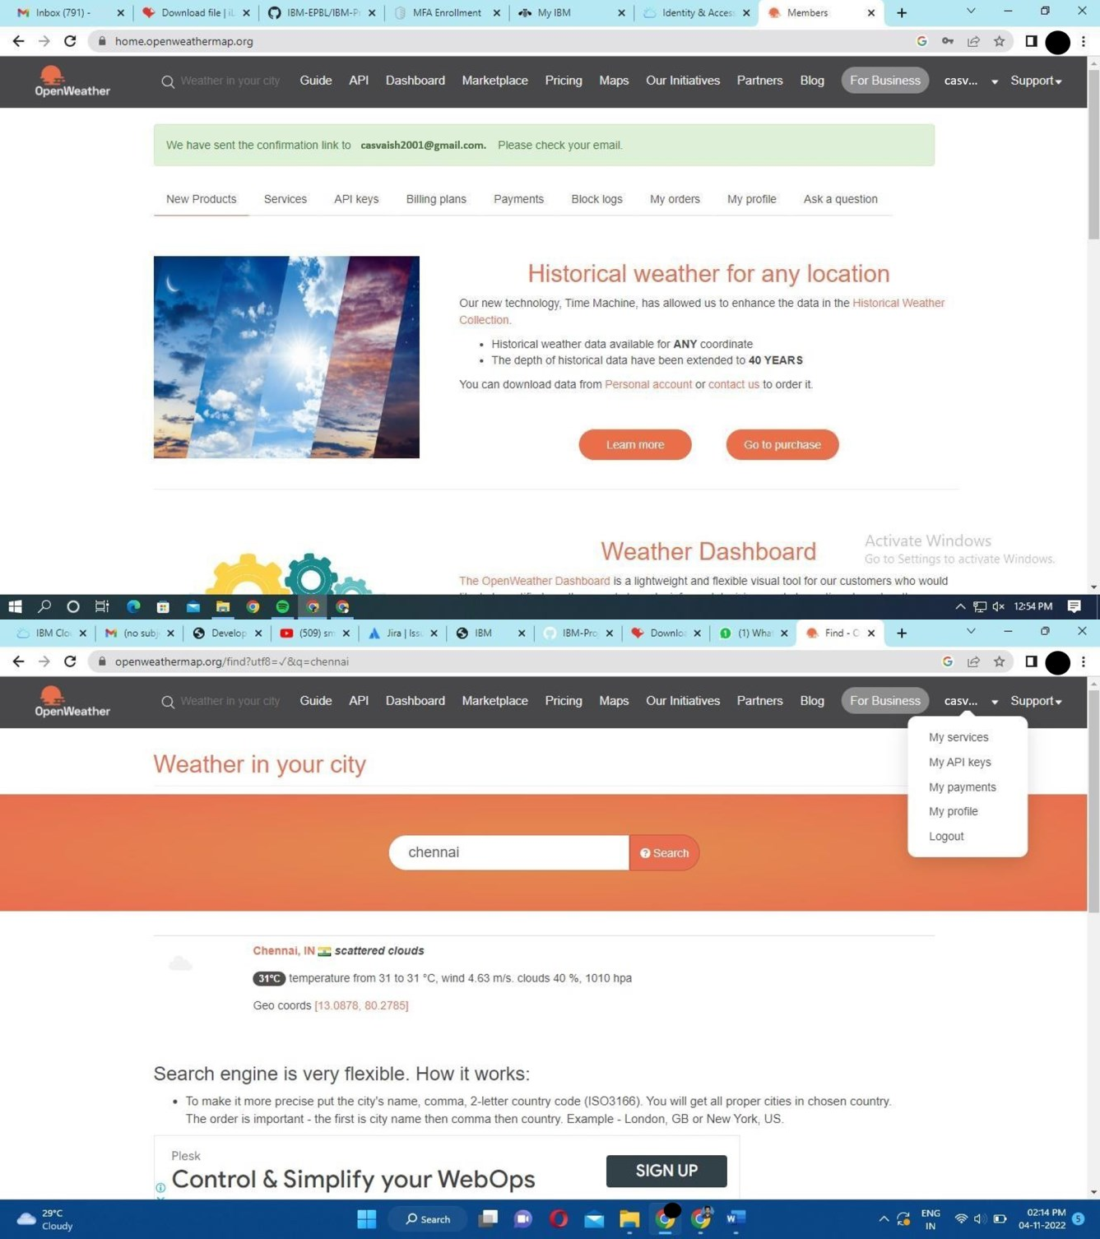

requests

a = " htt ps: ’lapi.open we athermap.org data 2.5'we at her?q = Chen na i, IN& ap pid =6d13d12f9cd34a07071 a579 5d01e2c47" r = requests.get(us = a)

data = r.json()

print(r)

print(data)

temp = data{"main”][”temp"] hum = data{”main"]{"humidity"] pnnt("Temperature is : ",temp) pnnt("Humidity is : ",hum)

< Response {200]» “

Temperature is : 298.14 s>>

===================== RESTART: E:/â BM/preMeatherMap.py =================

< Res ponse {200]»

{'coord': {'Toni 80.2785, 'Path 'I 3.0878}, 'weather’: [{'ids 701, 'main': 'Mist', 'descn ption':

'mist', 'icon': '5On'}, {’ids TOO, 'main': 'Rain', 'descn ption ’Tight rain', 'icons 'J On'}], 'bas e': 'stations’, 'mains {'tempt 298.14, 'feels liked 299.15, 'tern p min': 298.1 4, 'tern p ma z 298.14, 'pressured 'I O't 2, ’humidity': 94}, 'visibility': 2 TOO, 'wind': {'speed': 'I .54, 'deg

3 50}, 'rains {'1h': 0.12}, 'clouds {'aTT': 75}, 'dt': 'I 6673174 'I 6, 'sys': {'type': 1, 'id': 92 8,

'country': ' TN', 'sunnse 166726275 'I , 'sunsets ñ 667304738}, 'timezone': 19800, 'ids 1 264527, 'name': 'Chennai', 'cod': 200}

Mem perature is : 298.14 Humidity is : 94

